Secure Workflow for a Smart Agriculture Monitoring System Integrating IoT Sensors and Cloud Services
1. Introduction
Smart agriculture, also known as precision agriculture, uses Internet of Things (IoT) technologies, cloud computing, artificial intelligence (AI), and data analytics to improve farming efficiency and productivity. IoT sensors continuously collect environmental data such as soil moisture, temperature, humidity, rainfall, light intensity, pH level, and air quality. This information is transmitted to cloud platforms where it is processed to provide real-time recommendations for irrigation, fertilization, pest control, and crop health monitoring.
Although IoT-based agriculture offers numerous benefits, it also introduces significant security challenges. Since multiple sensors, gateways, cloud platforms, and user devices communicate over the Internet, attackers may attempt to intercept data, impersonate devices, manipulate sensor readings, or launch denial-of-service attacks. Therefore, a secure workflow is essential to ensure the confidentiality, integrity, and availability (CIA) of agricultural data.
The proposed secure workflow integrates IoT sensors with cloud services while implementing multiple layers of security, including authentication, encryption, access control, continuous monitoring, and disaster recovery. This architecture enables farmers to make accurate decisions while protecting sensitive agricultural information from cyber threats.

2. System Architecture
The smart agriculture monitoring system consists of five major layers.
Layer 1: Field Layer (IoT Sensors)
The field layer contains multiple IoT sensors deployed across agricultural land. These sensors continuously monitor environmental conditions.
Examples include:
- Soil Moisture Sensor
- Temperature Sensor
- Humidity Sensor
- Rainfall Sensor
- Light Intensity Sensor
- Air Quality Sensor
- pH Sensor
- Crop Camera (Image Sensor)
Each sensor periodically collects data and transmits it to the nearby IoT gateway.

Layer 2: Edge/Gateway Layer
The IoT gateway acts as an intermediary between sensors and cloud services.
Its responsibilities include:
- Collecting data from multiple sensors
- Filtering invalid or duplicate data
- Authenticating connected devices
- Encrypting transmitted data
- Forwarding data securely to the cloud
The gateway reduces network traffic and performs preliminary processing before cloud transmission.

Layer 3: Cloud Layer
The cloud platform receives sensor data through secure communication protocols.
Cloud services include:
- IoT Device Management
- Data Storage
- Data Analytics
- Machine Learning
- Alert Generation
- Security Monitoring
- Backup Services
The cloud stores historical agricultural data and generates intelligent recommendations.

Layer 4: Application Layer
Farmers and administrators access the system through:
- Web Dashboard
- Mobile Application
- Analytics Reports
- Notification System
This layer allows users to monitor crop conditions and receive real-time alerts.

Layer 5: Actuation Layer
Based on cloud recommendations, smart actuators automatically perform farming operations.
Examples include:
- Smart Irrigation System
- Water Pump Controller
- Fertilizer Dispenser
- Greenhouse Ventilation Controller
- Smart Spraying System
Automation reduces manual effort while improving farming efficiency.

3. Secure Workflow
The secure workflow consists of the following steps:
Step 1: Data Collection
IoT sensors continuously measure environmental conditions such as soil moisture, temperature, humidity, rainfall, and crop health.
Example:
- Soil moisture sensor detects 28% moisture.
- Temperature sensor records 34°C.

Step 2: Device Authentication
Before transmitting any data, every IoT sensor authenticates itself using digital certificates or secure device identities.
Security Mechanism:
- X.509 Certificates
- Mutual Authentication
- Device Identity Verification
Only trusted devices are allowed to communicate.

Step 3: Secure Communication
Sensor data is encrypted before transmission.
Communication protocols include:
- MQTT over TLS
- HTTPS
- CoAP over DTLS
- LoRaWAN Security
TLS 1.3 protects data from interception.

Step 4: Edge Processing
The IoT gateway performs:
- Data Validation
- Noise Removal
- Duplicate Detection
- Temporary Storage
- Local Decision Making
Invalid sensor readings are discarded before cloud transmission.

Step 5: Cloud Authentication
The cloud platform verifies:
- Device Identity
- Digital Certificates
- Access Tokens
Only authenticated gateways can upload data.

Step 6: Secure Cloud Storage
Sensor data is stored inside encrypted databases.
Security controls include:
- AES-256 Encryption
- Database Encryption
- Secure Backup
- Access Logging
Historical data remains protected even if storage is compromised.

Step 7: Data Analytics
Cloud analytics engines process:
- Real-Time Sensor Data
- Historical Data
- Weather Forecasts
- Machine Learning Models
The system predicts:
- Irrigation Schedule
- Fertilizer Requirement
- Disease Detection
- Crop Yield

Step 8: User Dashboard
Farmers access real-time information using:
- Mobile Application
- Web Dashboard
Displayed information includes:
- Soil Moisture
- Temperature
- Humidity
- Water Usage
- Crop Health
- Alerts
Role-Based Access Control (RBAC) ensures users only access authorized information.

Step 9: Alert Generation
If abnormal conditions are detected, notifications are sent immediately.
Examples:
- Low Soil Moisture Alert
- Heavy Rain Warning
- High Temperature Alert
- Device Offline Notification
Notifications are delivered via:
- SMS
- Email
- Push Notifications

Step 10: Smart Actuation
After farmer approval or predefined automation rules, the system performs actions such as:
- Starting irrigation
- Turning off water pumps
- Opening greenhouse ventilation
- Dispensing fertilizers
Automation improves efficiency while reducing water and energy consumption.

Step 11: Continuous Monitoring
Security monitoring includes:
- Intrusion Detection System (IDS)
- Security Information and Event Management (SIEM)
- Audit Logs
- Threat Intelligence
- Vulnerability Scanning
Continuous monitoring helps detect cyberattacks in real time.

Step 12: Backup and Disaster Recovery
Regular backups ensure business continuity.
Recovery mechanisms include:
- Automated Cloud Backup
- Disaster Recovery Site
- Database Replication
- High Availability
These measures minimize downtime and prevent data loss.

4. Security Controls
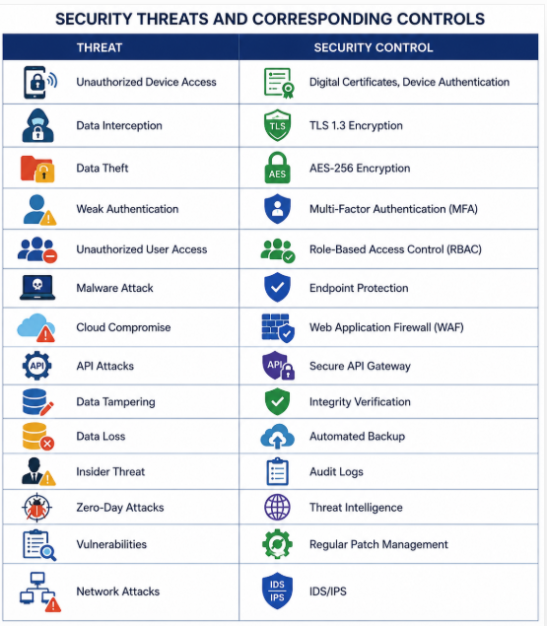
 | 
 | 
 | 
 | 
 | 
 | 
 | 
 | 
 | 
 | 
 | 
 | 
 | 
 | 
 | 

5. Advantages of the Secure Workflow
The proposed secure workflow provides several advantages:
- Ensures end-to-end encryption for secure communication.
- Prevents unauthorized device and user access.
- Enables real-time crop monitoring.
- Improves irrigation and fertilizer management.
- Supports predictive analytics using cloud computing.
- Provides automatic alert generation.
- Reduces manual farming effort through automation.
- Ensures secure cloud storage with encrypted backups.
- Supports scalability for large agricultural deployments.
- Improves overall reliability, availability, and operational efficiency.
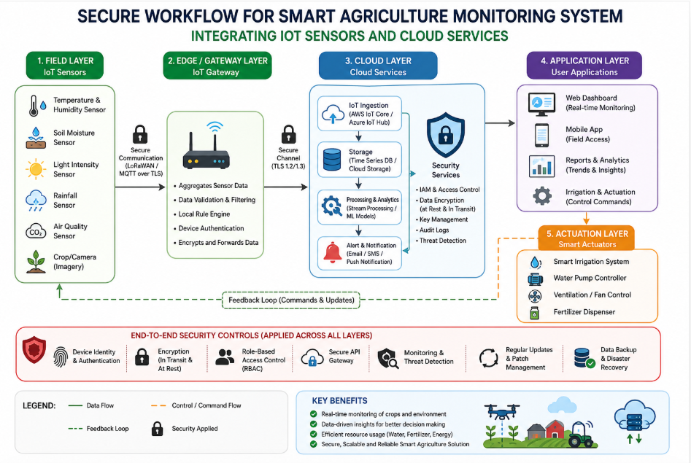
6. Conclusion
A secure workflow for a smart agriculture monitoring system combines IoT sensors, edge gateways, cloud computing, and smart actuators to create an intelligent and resilient farming environment. By integrating authentication, encryption, access control, secure cloud storage, continuous monitoring, and disaster recovery, the system protects agricultural data while enabling real-time decision-making and automated field operations.
This architecture not only improves crop productivity and resource utilization but also safeguards the system against cyber threats such as unauthorized access, data tampering, malware, and denial-of-service attacks. As precision agriculture continues to evolve, adopting a secure, scalable, and cloud-integrated workflow will be essential for sustainable farming, enhanced food security, and efficient agricultural management.

